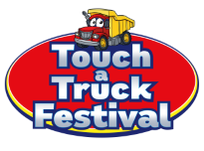
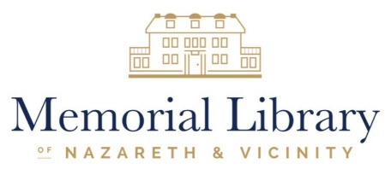

Dear Community Partner,
Since 2018, the Touch-a-Truck Festival (TATF) has been a cherished tradition in the Nazareth area, bringing together families, businesses, first responders, and community organizations for a day of fun, learning, and connection. More importantly, it has become a vital fundraiser that helps ensure the continued success of the Memorial Library of Nazareth and Vicinity.
I hope your business will consider becoming a sponsor and exhibitor for this year's Touch-a-Truck Festival, which will be held on Saturday, October 3, 2026, from 10:00 a.m. to 2:00 p.m. at the Bushkill Township Recreation Fields.
Touch-a-Truck is much more than a community event. It is the library's largest and most significant grass roots fundraiser. The funds raised through sponsorships, ticket sales, and community support allow the library to keep our library collection current, expand access to materials and technology, and offer innovative programs and services that enrich the lives of residents throughout our service area.
Because of the generosity of sponsors like you, the library continues to grow and thrive. In 2025 alone, we offered more than 300 youth programs and over 140 adult programs. We provide dynamic Summer Reading Programs for all ages, host baby and sensory story times that welcome and support young families, offer educational workshops, cultural experiences, technology assistance, and lifelong learning opportunities that serve thousands of community members each year.
The Memorial Library of Nazareth and Vicinity is recognized as a premier community resource because of the support we receive from dedicated partners like you, our local municipalities, and the many volunteers who generously contribute their time and talents. Your sponsorship dollars directly impact the quality of services we can provide and help ensure that the library remains a vibrant and welcoming place for everyone.
Touch-a-Truck regularly attracts more than 1,200 attendees and features over 80 vehicles, including emergency response units, construction equipment, military vehicles, public works equipment, and specialty vehicles from local businesses. The sight of these vehicles lined up across the recreation fields is a powerful reminder of the strength, service, and generosity that define our community.
This year, we hope to raise $30,000 to support the library's mission and services. We invite you to join us as a sponsor and exhibitor and become part of an event that has made a lasting impact on our community for nearly a decade.
To view highlights from previous Touch-a-Truck Festivals and learn more about sponsorship and exhibitor opportunities, please visit:
www.nazarethlibrary.org/touch-a-truck
Sponsorship opportunities are available now, with a deadline of August 1, 2026. We hope you will join us in making this year's Touch-a-Truck Festival our most successful yet.
Thank you for your continued support of the Memorial Library of Nazareth and Vicinity and the communities we serve.
Sincerely,
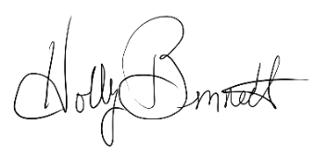
Holly T. Bennett
Executive Director
610-759-4932 ext. 6
hbennett@nazarethlibrary.org

